Table of Contents
core of Jboss ESB 1
Services and Messages 2
The Service 2
The Message 4
Getting and Setting Data on the Message Body 7
Extensions to Body 7
The Message Header 8
LogicalEPR 10
Default FaultTo 11
Default ReplyTo 11
Default ReplyTo by transport 11
The Message payload 11
The Message Factory 12
Message Formats 13

Core of Jboss ESB

- Message Listener and Message Filtering code.
Message Listeners act as “inbound” message routers that listen for messages (e.g. on a JMS Queue/Topic, or on the file system) and present the message to a message processing pipeline that filters the message and routes it (“outbound” router) to another message endpoint.

- Data transformation via the SmooksAction action processor.
Message Transformation on JBossESB is supported by the SmooksTransformer component. This
is an ESB Action component that allows the Smooks Data Transformation/Processing Framework
to be plugged into an ESB Action Processing Pipeline.

A wide range of source (XML, CSV, EDI etc.) and target (XML, Java, CSV, EDI etc.) data
formats are supported by the SmooksTransformer component. A wide range of Transformation
Technologies are also supported, all within a single framework.

- A Content Based Routing Service.
The Content-based Routing mechanism within JBossESB can be used to route Messages based on arbitrarily complex rules, which can be defined within XPath or Drools notation.

- A Message Repository,
In the context of SOA, a registry provides applications and businesses a central point to store
information about their services. It is expected to provide the same level of information and the
same breadth of services to its clients as that of a conventional market place. Ideally a registry
should also facilitate the automated discovery and execution of e-commerce transactions and
enabling a dynamic environment for business transactions. Therefore, a registry is more than an
“e-business directory”. It is an inherent component of the SOA infrastructure

Services and Messages

In keeping with SOA principles, everything within JBossESB is considered to be either a service or
a message. Services encapsulate the business logic or points of integration with legacy systems.
Messages are the way in which clients and services communicate with each other.

The Service
A “Service” in JBossESB is defined as a list of “Action” classes that process an ESB Message in
a sequential manner (see below). This list of Action classes is referred to as an “Action Pipeline”.
A Service can define a list of “Listeners”, which act as inbound routers for the Service, routing
messages to the Action Pipeline.

The following is a very simple JBossESB configuration that defines a single Service that simply
prints the contents of the ESB Message to the console.

<?xml version = "1.0" encoding = "UTF-8"?>

<jbossesb xmlns="http://anonsvn.labs.jboss.com/labs/jbossesb/trunk/product/etc/schemas/xml/
jbossesb-1.0.1.xsd" invmScope=#GLOBAL#>

<services>
<service category="Retail" name="ShoeStore" description="Acme Shoe Store Service">
<actions>
<action name="println" class="org.jboss.soa.esb.actions.SystemPrintln" />
</actions>
</service>
</services>

</jbossesb>

As you can see from the above example, a Service has “category” and “name” attributes.
When JBossESB deploys the Service, it uses these attributes to register the Service endpoints
(listeners) in the Service Registry (see Registry Guide). Clients can invoke the Service using the
ServiceInvoker as follows

ServiceInvoker invoker = new SERVICEINVOKER (#Retail#, #ShoeStore#);
Message message = MessageFactory.getInstance().getMessage();
message.getBody().add(#Hi there!#);
invoker.deliverAsync(message);

The ServiceInvoker uses the Service Registry (see ServicesGuide) to lookup the available
Endpoint addresses for the “Retail:ShoeStore” Service. It takes care of all the transport details of
getting the message from the Client to one of the available Service Endpoints (JMS, FTP, HTTP
etc), hiding all of the lower level details from the Client.
The Endpoint addresses made available to the ServiceInvoker will depend on the list of listeners
configured on the Service such as JMS, FTP or HTTP. No listeners are configured on the Service
in the above example, but its InVM listener has been enabled using invmScope="GLOBAL"1.
(The InVM transport is a new feature since JBossESB 4.3 that provides communication between
services running on the same JVM. The section on "InVM Transport" contains more information
about this feature.) To add additional Endpoints for the Service, we need to explicitly add listener
Configurations on the Service.

JBossESB supports two forms of listener configuration:

- Gateway Listeners
These listener configurations configure a “Gateway” Endpoint. These Endpoint types can be
used to get messages onto an ESB bus. It is responsible for “normalizing” the message payload
by wrapping it into an ESB Message (see below) before shipping it to the Service's Action
Pipeline.
- ESB-Aware Listeners
These listener configurations configure an “ESB Aware” Endpoint. These Endpoint types
are used to exchange ESB Messages (see below) between ESB Aware components e.g.
exchanging messages on the bus.
The following is an example of how a JMS Gateway listener can be added to the above ShoeStore
Service.

<?xml version = "1.0" encoding = "UTF-8"?>
<jbossesb xmlns="http://anonsvn.labs.jboss.com/labs/jbossesb/
trunk/product/etc/schemas/xml/jbossesb-1.0.1.xsd">

<providers>
<jms-provider name="JBossMQ" connection-factory="ConnectionFactory">
<jms-bus busid="shoeStoreJMSGateway">
<jms-message-filter dest-type="QUEUE" dest-name="queue/shoeStoreJMSGateway"/>
</jms-bus>
</jms-provider>
</providers>

<services>
<service category="Retail" name="ShoeStore" description="Acme Shoe Store Service"
invmScope="GLOBAL">

<listeners>
<jms-listener name="shoeStoreJMSGateway" busidref="shoeStoreJMSGateway"
is-gateway="true"/>
</listeners>

<actions>
<action name="println" class="org.jboss.soa.esb.actions.SystemPrintln" />
</actions>
</service>
</services>

</jbossesb>

In the above configuration, we added a bus <providers> section to the configuration. This is where
we configure the transport level details for Endpoints. In this case we added a <jms-provider>
section that defines a single <jms-bus> for the Shoe Store JMS Queue. This bus is then referenced
in the <jms-listener> defined on the Shoe Store Service. The Shoe Store is now invocable via two
Endpoints – the InVM Endpoint and the JMS Gateway Endpoint. The ServiceInvoker will always
use a Service's local InVM Endpoint, if available, in preference to other Endpoint types.

The Message

All interactions between clients and services within JBossESB occur through the exchange of
Messages. In order to encourage loose coupling we recommend a message-exchange pattern
based on one-way messages, i.e., requests and responses are independent messages, correlated
where necessary by the infrastructure or application. Applications constructed in this way are less
brittle and can be more tolerant of failures, giving developers more flexibility in their deployment
and message delivery requirements.

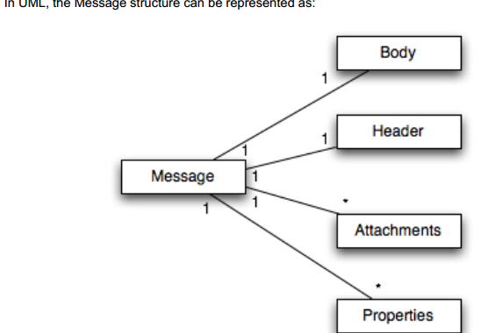

Each message is an implementation of the org.jboss.soa.esb.message.Message interface. Within
that package are interfaces for the various fields within the Message as shown below:

public interface Message
{
public Header getHeader ();
public Context getContext ();
public Body getBody ();
public Fault getFault ();
public Attachment getAttachment ();
public URI getType ();
public Properties getProperties ();
public Message copy () throws Exception;
}

- The Header contains routing and addressing information for this message

public interface Header
{
public Call getCall ();
public void setCall (Call call);
}

- The Context contains session related information, such as transaction or security contexts.

- The Body typically contains the payload of the message. It may contain a list of Objects of arbitrary types. How these objects are serialized to/from the message body when it is transmitted is up to the specific Object type.

public interface Body
{
public static final String DEFAULT_LOCATION = "org.jboss.soa.esb.message.defaultEntry";
public void add (String name, Object value);
public Object get (String name);
public byte[] getContents();
public void add (Object value);
public Object get ();
public Object remove (String name);
public void replace (Body b);
public void merge (Body b);
public String[] getNames ();
}
- The Fault can be used to convey error information.

public interface Fault
{
public URI getCode ();
public void setCode (URI code);

public String getReason ();
public void setReason (String reason);

public Throwable getCause ();
public void setCause (Throwable ex);
}

- A set of message properties, which can be used to define additional meta-data for the message.

public interface Properties
{
public Object getProperty(String name);
public Object getProperty(String name, Object defaultVal);

public Object setProperty(String name, Object value);
public Object remove(String name);

public int size();
public String[] getNames();
}

- Messages may contain attachments that do not appear in the main payload body. For example,
imagines, drawings, binary document formats, zip files etc. The Attachment interface supports
both named and unnamed attachments.

public interface Attachment
{
Object get(String name);
Object put(String name, Object value);

Object remove(String name);

String[] getNames();

Object itemAt (int index) throws IndexOutOfBoundsException;
Object removeItemAt (int index) throws IndexOutOfBoundsException
Object replaceItemAt(int index, Object value)
throws IndexOutOfBoundsException;

void addItem (Object value);
void addItemAt (int index, Object value)
throws IndexOutOfBoundsException;
public int getUnnamedCount();
public int getNamedCount();
}

Getting and Setting Data on the Message Body

- By default, all JBossESB 4.2.1GA+ components (Actions, Listeners, Gateways, Routers, Notifies
etc.) get and set data on the message through the messages “Default Payload Location”

- All ESB components use the MessagePayloadProxy to manage getting and setting of the payload
On the message.

- get-payload-location: The location from which to retrieve the message payload.
- set-payload-location: The location on which to set the message payload.

Extensions to Body

As well as the basic Body interface, JBossESB supports the following interfaces, which are
extensions on the basic Body interface:

Extensions Types

org.jboss.soa.esb.message.body.content.TextBody
the content of the Body is an arbitrary String, and can be manipulated via the getText and
setText methods.
org.jboss.soa.esb.message.body.content.ObjectBody
the content of the Body is a Serialized Object, and can be manipulated via the getObject and
setObject methods.
org.jboss.soa.esb.message.body.content.MapBody
the content of the Body is a Map<String, Serialized), and can be manipulated via the setMap
and other methods.
org.jboss.soa.esb.message.body.content.BytesBody
the content of the Body is a byte stream that contains arbitrary Java data-types. It can be
manipulated using the various setter and getter methods for the data-types. Once created,
the BytesMessage should be placed into either a read-only or write-only mode, depending
upon how it needs to be manipulated. It is possible to change between these modes (using
readMode and writeMode), but each time the mode is changed the buffer pointer will be reset.
In order to ensure that all of the updates have been pushed into the Body, it is necessary to
call flush when finished

The Message Header

As we saw above, the Header of a Message contains a reference to the
org.jboss.soa.esb.addressing.Call class:

public class Call
{
public Call ();
public Call (EPR epr);
public Call (Call copy);
public void setTo (EPR epr);
public EPR getTo () throws URISyntaxException;
public void setFrom (EPR from);
public EPR getFrom () throws URISyntaxException;
public void setReplyTo (EPR replyTo);
public EPR getReplyTo () throws URISyntaxException;
public void setFaultTo (EPR uri);
public EPR getFaultTo () throws URISyntaxException;
public void setRelatesTo (URI uri);
public URI getRelatesTo () throws URISyntaxException;
public void copy();
public void setAction (URI uri);
public URI getAction () throws URISyntaxException;
public final boolean empty();
public void setMessageID (URI uri);
public URI getMessageID () throws URISyntaxException;
public String toString();
public String stringForum();
public boolean valid();
public void copy (Call from);
}

The properties below support both one way and request reply interaction patterns:

org.jboss.soa.esb.addressing.Call Properties
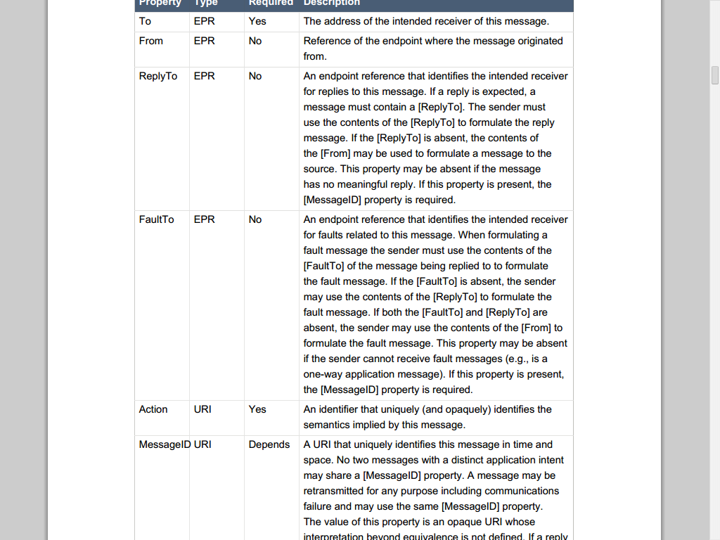
is expected, this property must be present

URI : Uniform resource identifier

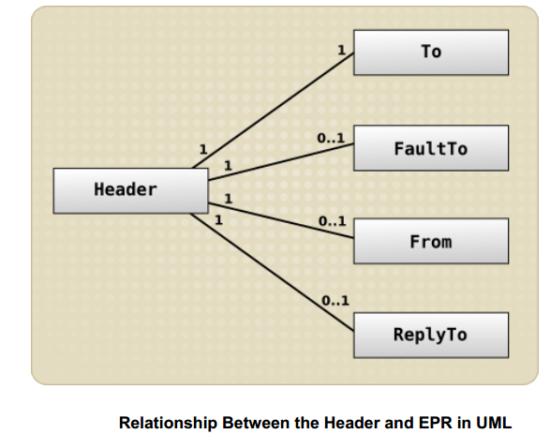

LogicalEPR

A LogicalEPR is an EPR that simply specifies the name and category of an ESB Service/Endpoint.
It contains no physical addressing information.
Clients setting the ReplyTo or FaultTo EPRs should always use the LogicalEPR, as opposed to
one of the Physical EPRs (JMSEpr etc). The LogicalEPR is the preferred option because it makes
no assumptions about the capabilities of the user of the EPR (typically the ESB itself, but not
necessarily), or when the EPR will be used i.e. a physical EPR may no longer be valid by the time
it gets used. By it's non-Physical nature, a LogicalEPR is also a lot easier to “handle” from a user
perspective. The user of the LogicalEPR can use the Service name and category details supplied
in the EPR to lookup the physical endpoint details for that Service/Endpoint at the point in time
when they intend making the invocation i.e. they will get relevant addressing information. The user
will also be able to select an endpoint type that suits it i.e. if it's easier for the user to make the
invocation using a file based transport (Vs e.g. JMS), then they can select that type of transport.

Default FaultTo

When sending Messages, it is possible that errors will occur, either during the transmission or
reception/processing of the Message. JBossESB will route any faults to the EPR mentioned in the
FaultTo field of the incoming message. If this is not set, then it will use the ReplyTo field or, failing
that, the From field. If no valid EPR is obtained as a result of checking all of these fields, then the
error will be output to the console. If you do not wish to be informed about such faults, such as
when sending a one-way message, you may wish to use the DeadLetter Queue Service EPR as
your FaultTo. In this way, any faults that do occur will be saved for later processing.

Default ReplyTo

Because the recommended interaction pattern within JBossESB is based on one-way message
exchange, responses to messages are not necessarily automatic: it is application dependent as The Message payload to whether or not a sender expects a response. As such, a reply address (EPR) is an optional part of the header routing information and applications should be setting this value if necessary. However, in the case where a response is required and the reply EPR (ReplyTo EPR) has not
been set, JBossESB supports default values for each type of transport. Some of these ReplyTo
defaults require system administrators to configure JBossESB correctly.

Default ReplyTo by transport
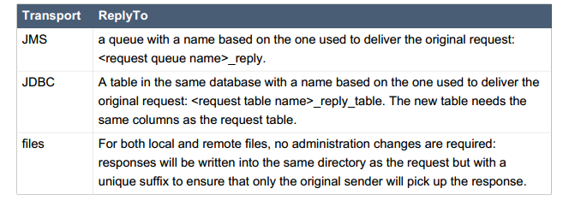

The Message payload

From an application/service perspective the message payload is a combination of the Body and
Attachments.

More complex content may be added through the add method, which supports named Objects.
Using <name, Object> pairs allows for a finer granularity of data access.

- The type of Objects that can be added to the Body can be arbitrary: they do not need to be Java Serializable. However, in the case where non-Serializable Objects are added, it is necessary to provide JBossESB with the ability to marshal/unmarshal the Message when it flows across the network.

- If no name is supplied to set or get, then the default name defined by DEFAULT_LOCATION will
be used.

- In the current release of JBossESB only Java Serialized objects may be attachments. This restriction will be removed in a subsequent release

In general you will find it easier to work with the Message Body through the named Object approach. You can add, remove and inspect individual data items within the Message payload without having to decode the entire Body.

The Message Factory

Internally to an ESB component, the message is a collection of Java objects. However, messages
need to be serialized for a number of reasons, e.g., transmitted between address spaces
(processes) or saved to a persistent datastore for auditing or debugging purposes. The external
representation of a message may be influenced by the environment in which the ESB is deployed.
Therefore, JBossESB does not impose a specific normalized message format, but supports a
range of them.

All implementations of the org.jboss.soa.esb.message.Message interface are obtained from the
org.jboss.soa.esb.message.format.MessageFactory class:

org.jboss.soa.esb.message.format.MessageFactory

public abstract class MessageFactory
{
public abstract Message getMessage ();
public abstract Message getMessage (URI type);
public abstract void reset();
public static MessageFactory getInstance ();
}

Message serialization implementations are uniquely identified by a URI. The type of
implementation required may be specified when requesting a new instance, or the configured
default implementation may be used.

Currently JBossESB provides two implementations, which are defined in the

org.jboss.soa.esb.message.format.MessageType class:

• MessageType.JBOSS_XML: this uses an XML representation of the Message on the wire. The
schema for the message is defined in the message.xsd within the schemas directory. The URI
is urn:jboss/esb/message/type/JBOSS_XML.

• MessageType.JAVA_SERIALIZED: this implementation requires that all components of a
Message are Serializable. It obviously requires that recipients of this type of Message have
sufficient information (the Java classes) to be able to de-serialize the Message. The URI is
urn:jboss/esb/message/type/JAVA_SERIALIZED.

Message Formats

JBossESB supports two serialized message formats:
MessageType.JBOSS_XML(Default Message Type ) and MessageType.JAVA_SERIALIZED

The default Message type is JBOSS_XML. However, this can be changed by
Setting the property org.jboss.soa.esb.message.default.uri to the desired URI.

MessageType.JAVA_SERIALIZED

This implementation requires that all contents are Java Serializable. Any attempt to add a non-
Serializable object to the Message will result in a IllegalParameterException being thrown.
It also requires that all contents be Java-serializable. Any attempt to add a non-serializable object
to the Message will result in an IllegalParameterException being thrown.
The URI for it is urn:jboss/esb/message/type/JAVA_SERIALIZED.

MessageType.JBOSS_XML

This implementation uses an XML representation of the Message on the wire. The schema
for the message is defined in the message.xsd within the schemas directory. Arbitrary
objects may be added to the Message, i.e., they do not have to be Serializable. Therefore,
it may be necessary to provide a mechanism to marshal/unmarshal such objects to/from
XML when the Message needs to be serialized. This support can be provided through the

org.jboss.soa.esb.message.format.xml.marshal.MarshalUnmarshalPlugin:
public interface MarshalUnmarshalPlugin
{
public static final String MARSHAL_UNMARSHAL_PLUGIN =
"org.jboss.soa.esb.message.format.xml.plugin";
public boolean canPack(final Object value);
public boolean marshal (Element doc, Object param)
throws MarshalException;
public Object unmarshal (Element doc) throws UnmarshalException;
public URI type ();
}
Plug-ins can be registered with the system through the jbossesb-properties.xml configuration file.
They should have attribute names that start with the MARSHAL_UNMARSHAL_PLUGIN. When
packing objects in XML, JBossESB runs through the list of registered plug-ins until it finds one
that can deal with the object type (or faults). When packing, the name (type) of the plug-in that
packed the object is also attached to facilitate unpacking at the Message receiver.

Building and Using Services

Listeners
Listeners encapsulate the endpoints for ESB-aware message reception. Upon receipt of a
message, a Listener feeds that message into a “pipeline” of message processors that process
the message before routing the result to the “replyTo” endpoint. The action processing that takes
place in the pipeline may consist of steps wherein the message gets transformed in one processor,
some business logic is applied in the next processor, before the result gets routed to the next step
in the pipeline, or to another endpoint.
Routers
Routers are the way in which either the ESB Message itself of its payload can be routed to
an endpoint. Some routers support the 'unwrap' property. If this property is true then the ESB
Message payload will be extracted and only the payload will be sent to the ESB-unaware endpoint.
Setting 'unwrap' to false will pass the ESB Message as is and the receiving endpoint must be
ESB-aware so that it can deal with the message.

No further processing of the action pipeline will occur after the router action even if you there are
action after it in the configuration. If this sort of splitting is required you should use the StaticWiretap
action.

Other routers like StaticWiretap, StaticRouter are only for routing to other services. There are
also router that can be used for dynamic routing based on the message content

Notifiers

